***VEHICLE MANAGEMENT SYSTEM***

1 INTRODUCTION

1.1 Overview

Vehicle Management system is an application where a customer details are stored in-order to choose two wheelers or four wheelers and commercials vehicle for travel within the city. The data here which is stored for further used to remind them if any updates regarding vehicles, that will sent to them via messages and mails.

1.2 Purpose

A vehicle management system is a software system or platform that serves to manage vehicles such as cars, vans or trucks or even heavy equipment to ensure they’re utilized safely , efficiently and professionally, while making sure they’re well maintained and high performing.

**2 PROBLEM DEFINITION AND DESIGN THINKING**

2.1 EMPATHY MAP

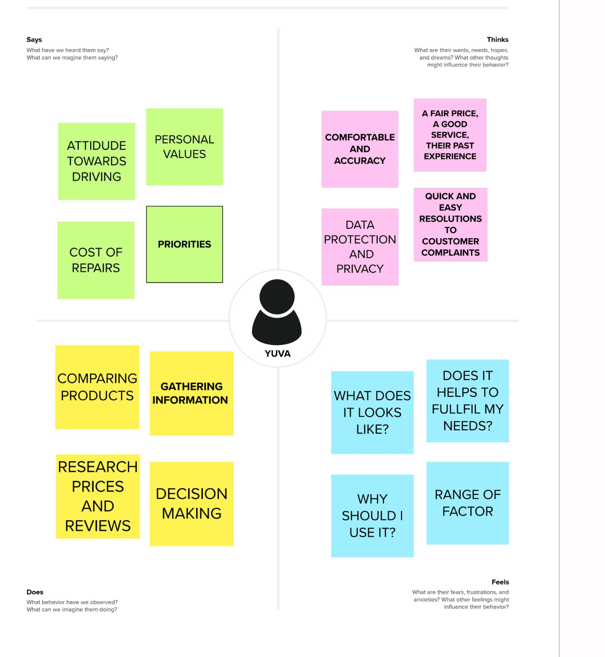

2.2 IDEATION AND BRAINSTORMING MAP

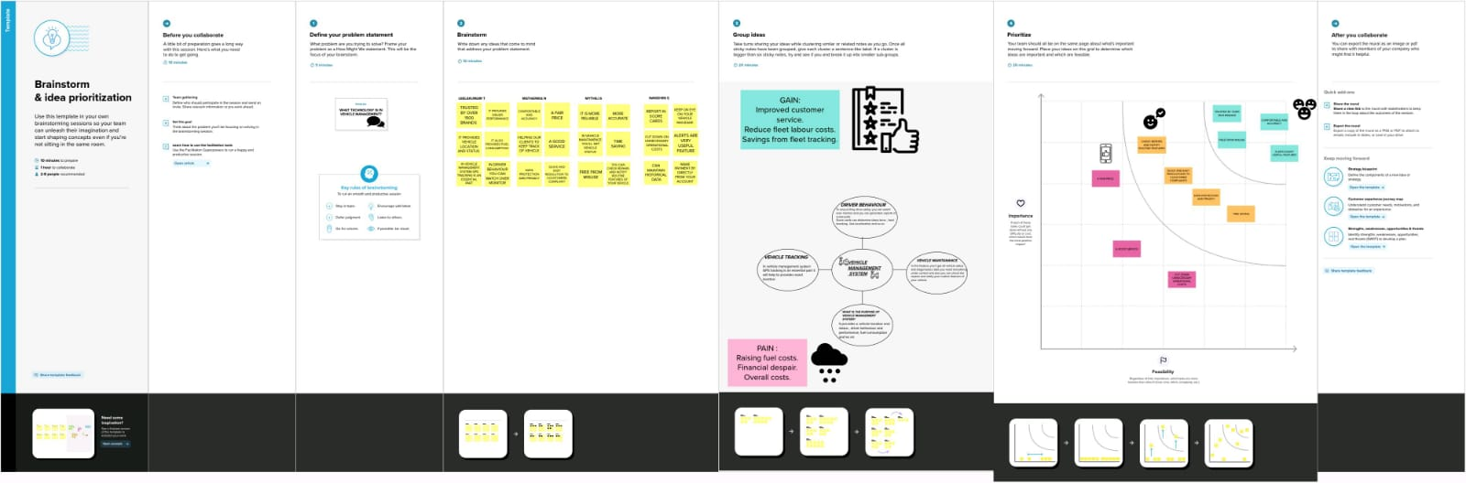

**3 RESULT**

3.1 DATA MODEL

|  |  |
| --- | --- |
| Object name | Fields in the object |
| COUSTOMER | |  |  | | --- | --- | | Field label | Data type | | Customer name | XXXXX | | Customer Mobile no | 1234567890 | |
| VEHICLES | |  |  | | --- | --- | | Field label | Data type | | Vehicle type   1. 2 wheeler 2. 4 wheeler | Picklist | | Vehicle name | XXXXX | |

|  |  |  |  |  |  |  |  |  |  |  |  |  |  |  |  |  |  |  |  |  |  |  |  |  |  |
| --- | --- | --- | --- | --- | --- | --- | --- | --- | --- | --- | --- | --- | --- | --- | --- | --- | --- | --- | --- | --- | --- | --- | --- | --- | --- |
|  | |  |  | | --- | --- | | 2 wheelers   1. Hero 2. Honda 3. Bajaj 4. Royal Enfield 5. TVS | Picklist | | 4Wheelers   1. Renault 2. Hyundai 3. Mahindra 4. Suzuki 5. Benz 6. Audi | Picklist | | Vehicle No | xxxxx | | Chassic No | xxxxx | | Colour | VIBGYOR | | Body type | xxxxx | | Vehicle includes   1. Fire extenuation 2. First aid kit 3. Stepney 4. Stereo 5. Tool kit 6. Tracking device 7. Tyre jack | Picklist  Picklist | | Condition   1. Good 2. Medium 3. least | Picklist | | Mileage | xxxxx | | Seats | Number | | Start date | Date/time | | End date | Date/time | |

**3.2 ACTIVITY AND SCREENSHOT**

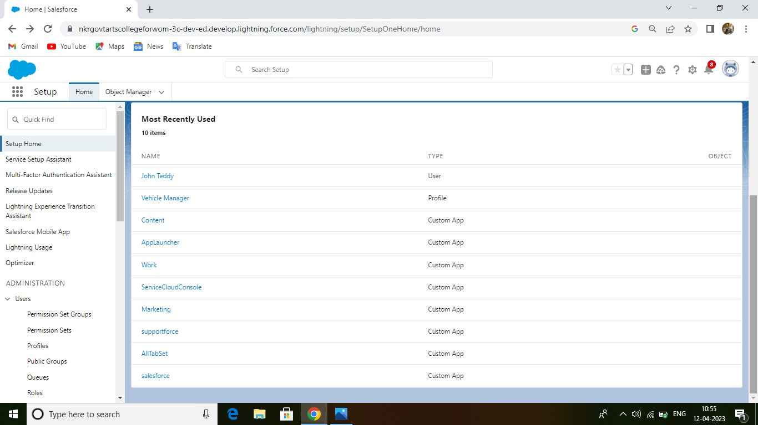

In this picture you can see what are the activities that we all used and what we all learn about that.

And also we upload a picture of each activities and its description.

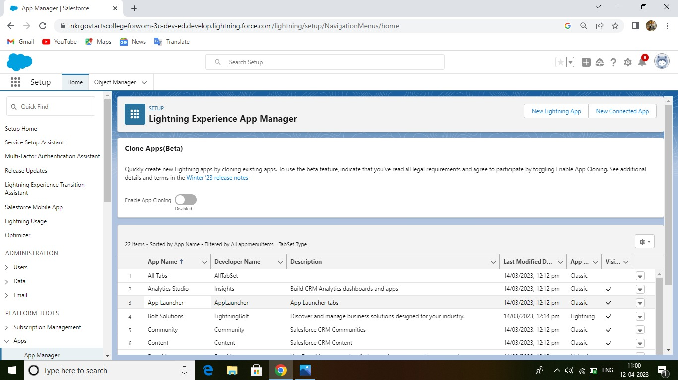

**Description:**

**In this activity, you will learn about lightning experience and app manager.**

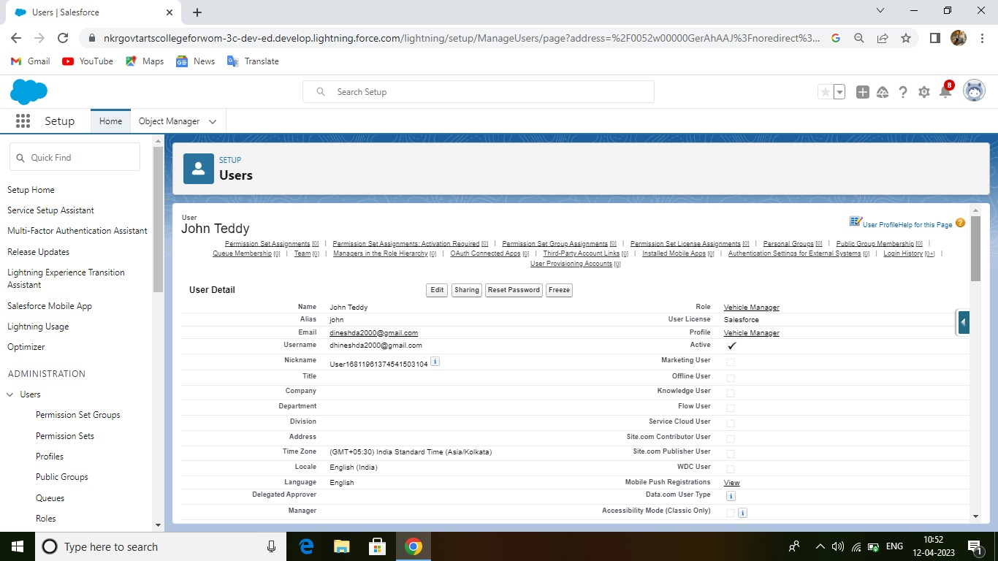

**DESCRIPTION:**

In this, this describes about the process of users.



**DESCRIPTION:**

In this features you’ll know about the process of what are the content that we have used.



**DESCRIPTION:**

In this you’ll know about, what are the work that we have done in this project.



**DESCRIPTION:**

In this features that you can see what are the marketing that we have used.



**DESCRIPTION:**

In this process you know about supportive force, how it ll work for supports.



DESCRIPTION:

In this you know about the process which are used in sales force.



**DESCRIPTION:**

Here, we used the theory of service cloud console that will help to know the process of everything.



DESCRIPTION:

In this activity we upload a process of everything that has all tab set.

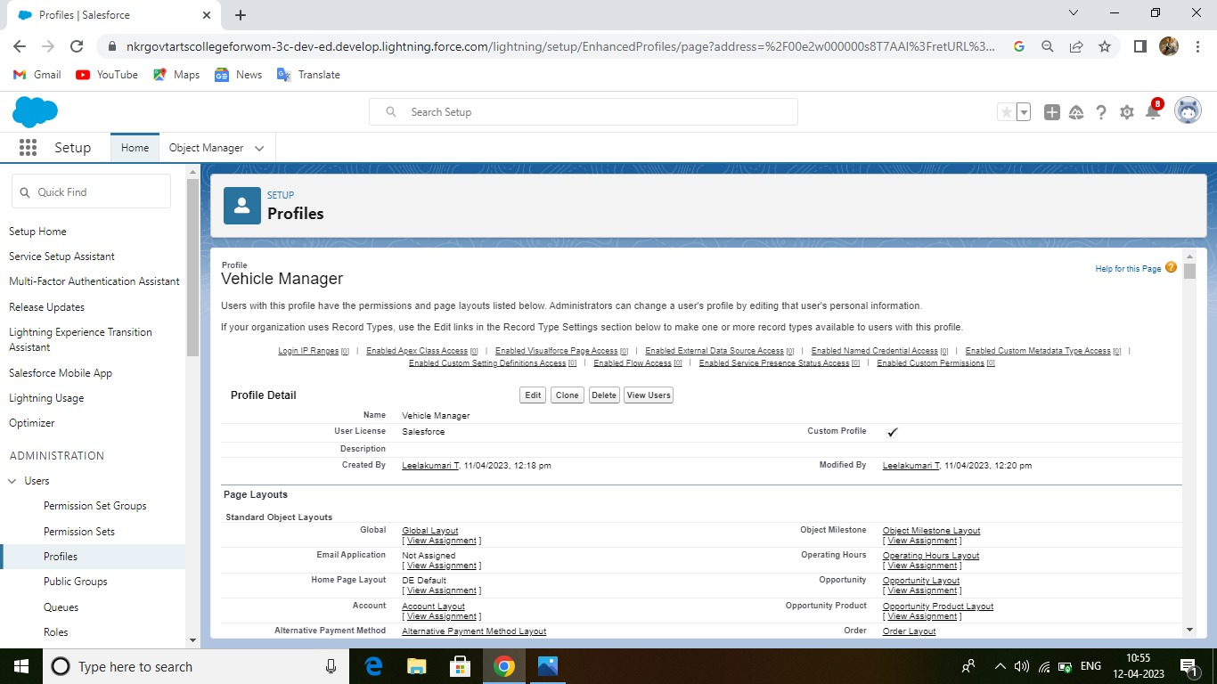

**DESCRIPTION:**

In this activity you will learn about the process of profiles, which are used in vehicle manager.

**4** **TRAILHEAD PROFILE PUBLIC URL**

**Team Lead (MYTHILI S) -** [**https://trailblazer.me/id/msenthil19**](https://trailblazer.me/id/msenthil19)

**Team Member 1(LEELAKUMARI T)-** [**https://trailblazer.me/id/leelt3**](https://trailblazer.me/id/leelt3)

**Team Member 2 (MATHANIKA N)-** [**https://trailblazer.me/id/mathn7**](https://trailblazer.me/id/mathn7)

**5 ADVANTAGES**

* It provides GPS tracking system , that helps you to know the location.
* Timely notifying regarding malfunctions and delays.
* Notifying an any issue, any indication of malfunction and any sign that a driver forget to check oil and fuel levels, lights and indicator and tire pressure before they left the lot.
* Having a driving behavior report or a scorecard helps identifying the behavior.
* Reduced maintenance and labor cost.
* Tax deduction and insurance benefits.

**DISADVANTAGES**

Using vehicle management system is an ideal choice. But still it does come with some disadvantages as well.

* As with all software systems, it also comes with a certain learning curve. Some systems can be so complicated that without aid from the software provider, you might not unlock the true potential of the tool at hand.
* Surely you will gain a lot from using athis management system. The profits you’ll make due to the software aid will eventually make up for the initial cost might seem like too much.
* You’ll face some issues, if you don’t have proper infrastructure.

**6 APPLICATIONS**

* It will surely comfortable and accuracy.
* It also has a fair and good price, a good service.
* We also provide a data protection and privacy.
* Regular feedback on performance from customers.
* Its free from misuse.
* Cut down an unnecessary operational costs.
* Make payment by directly from your account and also available cash.

**7 CONCLUSION**

In this system the transport management, designed and developed a low cost system based on integration of GPS data is described. The system consists of different models which are linked wirelessly. This enables the transport management centers to observe, collect, and analyze location information about a commuter vehicle in real time.

**8 FUTURE SCOPE**

* This project can be enhanced for tracking the vehicle speed on the roads.
* The camera can be used for security.